APPLICATION FORM

What Works

Enhancing Quality Funding Scheme Application Form

The What Works Enhancing Quality Fund is open for applications until August 22 2025. Awards are subject to funding availability and the volume and quality of applications received.
Please read the What Works Enhancing Quality Fund Guidance Notes and Terms & Conditions before completing this application.

Please note grant applications must be submitted by the deadline of August 22 2025 by email only to whatworks@dcde.gov.ie. The email must be sent from, or cc, the signatory to the Application.

All applications received will be sent a receipt of acknowledgement. We ask all applicants who do not receive a receipt to contact us directly at whatworks@dcde.gov.ie or by calling the Department at +353 1 6473000 and asking for the What Works team.

Grant allocations will be once-off and a minimum of €5,000 and a maximum of €30,000 is available per applicant. Only one application per organisation will be considered. Ongoing funding will not be available.

This fund is available only to not-for-profit organisations. Applications from private providers will not be considered.

All funding must be expended within a 12-month period from the date of the letter of award. Funding that has not been fully spent by this date must be de-committed i.e. returned to the Department of Children, Disability and Equality (DCDE).

Please make sure that your application:
- is completed in full and dated – incomplete applications will be considered ineligible;
- is signed by the person authorised to enter into legally binding commitments on behalf of the applicant;
- and meets the core criteria set out in the Guidance document and accompanying Terms and Conditions.

For queries please contact whatworks@dcde.gov.ie

Please complete this form in block letters:

Is your Organisation registered in the Republic of Ireland? | Choose an item.
Will the project to be funded be based in the Republic of Ireland? | Choose an item.
Will the project to be funded have its main impact in the Republic of Ireland? | Choose an item.
Name of project: | Click or tap here to enter text.
Amount of funding sought: €  Maximum amount available per available per applicant: €30,000  Minimum amount available per available per applicant: €5,000 | Click or tap here to enter text.

- ORGANISATION’S DETAILS

Name of Organisation
(lead organisation in the case of application by consortia):
Click or tap here to enter text.

Legal Name of Organisation:
Click or tap here to enter text.

Please provide detail of any membership of consortia, including membership of Child and Family Support Networks and of Children and Young People’s Services Committees (CYPSC) (if applicable):
Click or tap here to enter text.
Address of Lead Organisation:
Click or tap here to enter text.

Contact email address: (Please note all communications in relation to the Organisation/Project will go to this email address. Any changes to contact details should be provided via email to whatworks@dcde.gov.ie)
Click or tap here to enter text.
Contact telephone number: (Please note we may use the contact telephone number provided to communicate in relation to the project. Any changes to contact details should be provided via email to whatworks@dcde.gov.ie)
Click or tap here to enter text.

- PROJECT DESCRIPTION

- Project Title*
Please enter the title of your project.
Click or tap here to enter text.

- What thematic area(s) does your project cover? (e.g. parenting, early learning and childcare, mental health, etc)

Click or tap here to enter text.

- Evidence of Need to be Addressed*

Please outline the need you are addressing, including evidence provided for this need, and any issues or difficulties faced as a result. Data-based evidence is particularly welcomed. Please note that projects must incorporate a prevention and early intervention approach (200 words max).

Click or tap here to enter text.

- Description of Proposed Project Methodology*

Please provide a brief description of your project and the proposed methodology that would be undertaken in the course of your project. Please include the proposed sets of data to be collected and analysed (200 words max).

Click or tap here to enter text.

- What is the expected reach of this project?*

This should include information such as the numbers of participants, service providers etc. that will be impacted by the project. Include any evidence for this (200 words max).

Click or tap here to enter text.

- What is the anticipated long-term impact of this project?*

Please indicate the measures that will be used to assess the impact of the project. This should include information on the scalability, sustainability and replicability of the planned activities, as well as how the project will improve service quality over the longer term (200 words max).

Click or tap here to enter text.

- How will service users be included in your methodology?

Please detail the ways in which you plan to include the voice and participation of stakeholders, including children, to inform your methodology (200 words max).

Click or tap here to enter text.

- Please detail how the outcomes of this project may be used to improve outcomes for children and young people and improve service provision.

Please detail the ways in which this project will contribute towards improved outcomes for children and young people in your area (200 words max).

Click or tap here to enter text.

- Please outline how your project is relevant to the theme of ‘Enhancing Quality’, and how it complies with Government initiatives such as the What Works initiative and Young Ireland.

Please describe the connections your project has with relevant local and national policies (200 words max).

Click or tap here to enter text.

How did you hear about us?

Please let us know how you heard about the What Works Enhancing Quality Fund.

Click or tap here to enter text.

- TIMELINE
Activity | Projected Date
Click or tap here to enter text. | Click or tap here to enter text.
Click or tap here to enter text. | Click or tap here to enter text.
Click or tap here to enter text. | Click or tap here to enter text.
Click or tap here to enter text. | Click or tap here to enter text.
Click or tap here to enter text. | Click or tap here to enter text.
Click or tap here to enter text. | Click or tap here to enter text.
Click or tap here to enter text. | Click or tap here to enter text.
Click or tap here to enter text. | Click or tap here to enter text.

BUDGET

Enhancing Quality Fund – Budget costs 2025/2026
Proposed Activities | Cost Rationale: | Estimated Cost:
Training of staff | Click or tap here to enter text. | Click or tap here to enter text.
Staff costs (for the duration of the contract) | Click or tap here to enter text. | Click or tap here to enter text.
Upskilling training sessions | Click or tap here to enter text. | Click or tap here to enter text.
Researcher fees | Click or tap here to enter text. | Click or tap here to enter text.
Venue Hire/ Online Platforms | Click or tap here to enter text. | Click or tap here to enter text.
Administration costs – not to exceed 15% of the overall funding | Click or tap here to enter text. | Click or tap here to enter text.
Small IT equipment including software – not to exceed 10% of the budget | Click or tap here to enter text. | Click or tap here to enter text.
Media production costs (e.g. podcasts) | Click or tap here to enter text. | Click or tap here to enter text.
Other eligible costs (insert rows as necessary) | Click or tap here to enter text. | Click or tap here to enter text.
Item 1: | Click or tap here to enter text. | Click or tap here to enter text.
Item 2: | Click or tap here to enter text. | Click or tap here to enter text.
Item 3: | Click or tap here to enter text. | Click or tap here to enter text.
Total cost of project: |  | Click or tap here to enter text.

Please state any previous funding received for this project.
Click or tap here to enter text.
Tax Clearance details:
Tax Registration Number: Click or tap here to enter text.
Tax Clearance Access Number: Click or tap here to enter text.
CHY Number (if appropriate): Click or tap here to enter text.
Organisation Bank details:
Account name Click or tap here to enter text.
Name of Bank Click or tap here to enter text.
Address of Bank Click or tap here to enter text.
IBAN number Click or tap here to enter text.
BIC Code: Click or tap here to enter text.

- Outside Funding
Please outline any other sources of once-off funding received by your organisation in 2025 and outline the title of the project allocated to this funding.
Source | Amount and project title
Click or tap here to enter text. | Click or tap here to enter text.
Click or tap here to enter text. | Click or tap here to enter text.
Click or tap here to enter text. | Click or tap here to enter text.
Click or tap here to enter text. | Click or tap here to enter text.
Click or tap here to enter text. | Click or tap here to enter text.
Click or tap here to enter text. | Click or tap here to enter text.
Click or tap here to enter text. | Click or tap here to enter text.
Click or tap here to enter text. | Click or tap here to enter text.

Data Management*
In order to review your submission, DCDE will need to share it with DCDE staff and its review panel. DCDE will also contact you regarding the processing of this submission. All personal data will be stored in accordance with DCDE GDPR policy, which can be viewed on https://www.gov.ie/en/organisation-information/68bb14-department-of-children-and-youth-affairs-data-protection/ Details of this policy are also available in hard copy upon request to Department of Children, Equality, Disability, Integration and Youth, Block 1, Miesian Plaza, 50 – 58 Baggot Street Lower, FREEPOST F5055, Dublin 2, D02 XW14.

Do you agree with these terms?
Yes
No

- DECLARATION OF ACCEPTANCE

Please read the accompanying Terms and Conditions document of the What Works Funding Scheme before signing this Declaration. It can be found with the What Works Funding Scheme Guidelines and Application Form on the What Works website

On behalf of Click or tap here to enter text. (insert name of the service/organisation), we apply for a once-off grant for the purpose stated above and declare that the information given in this application is true and complete to the best of our knowledge and belief. We consent to Department of Children, Disability and Equality (DCDE) making enquiries to a third party if necessary regarding details of the funding application.

We understand that information supplied in or accompanying this application may be made available on request under the Freedom of Information Acts 1997 and 2003. We also understand that making application is no guarantee of funding.
We also accept, as a condition for the award of a grant, that it involves no commitment to any other grants from the DCDE or from any Government Department. The project sponsors are agreeable to have the project monitored by the DCDE and to allow access to its premises and records, as necessary, for that purpose.
If funding is approved, we agree and confirm that we will manage the grant in accordance with the conditions. We will comply with the terms of Department of Public Expenditure and Reform (DPER) Circular 13/2014 and all relevant financial procedures and legislation, in particular the Children First Act 2015 and Children First National Guidance, and also including but not limited to:
- National Vetting Bureau (Children and Vulnerable Persons) Act 2012;
- Criminal Justice (Withholding of Information on Offences against Children and Vulnerable Adults) Act 2012 and any other child protective measures and legislation;
- Public procurement guidelines;
- Taxation legislation including income tax and withholding tax;
- Tax clearance procedures including Dept. of Finance Circular 44/2006;
- Employment and pensions legislation;
- Prompt payment of accounts;
- General Data Protection Regulation (GDPR) (EU) 2016/679, the Data Protection Acts 1988-2018, and any guidelines and codes of practice issued by the Data Protection Commission in Ireland from time to time.
- The Protected Disclosures Act 2014 (amended 2022).
We will ensure that proper accounts are kept and audited and are available for inspection by DCDE if required

We agree to seek value for money and to abide by the public procurement guidelines. The funds will be applied for the purposes set out in our application and we undertake that funding from any other source will not be used for the same purpose. In the event that we are unable to spend the grant for the purposes set out in our application, we agree to return the grant. We understand that the DCDE may seek the refund of the grant if we fail to comply with these conditions.

We acknowledge that any funds awarded are subject to such funds being available to the DCDE and that they must be used within a 12 month period beginning on the date of the contract being in place with DCDE and for the purpose stated and not to replace existing funding and we will acknowledge the support we have received from the DCDE and Dormant Accounts in all publicity in relation to our project as set out in the Terms and Conditions of this fund.
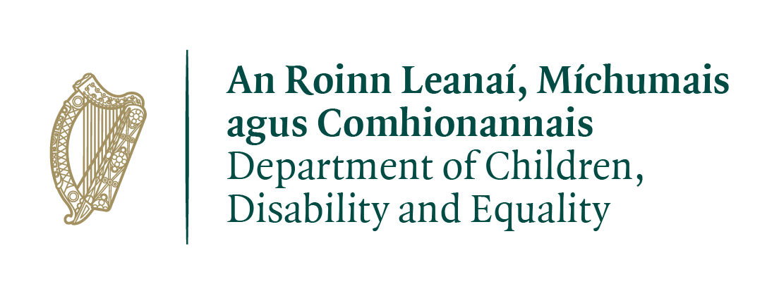
The DCDE does not make any claim to intellectual property arising from the Award. It is a condition of funding that applicants provide a report for publication on the What Works website, as well as a short video describing the project and its outcomes.

We hereby apply for grant funding and accept the accompanying Terms and Conditions of this fund:

Signed: Click or tap here to enter text. (CEO, Director or Chairperson)
(The email must be sent from, or cc, the signatory to the Application)

Position: Click or tap here to enter text.

Date: Click or tap here to enter text.

